AI Camera 2.0 Basic Projects

Lesson 5: Tag Detection
Ages: 12 and up
Duration: 45 minutes

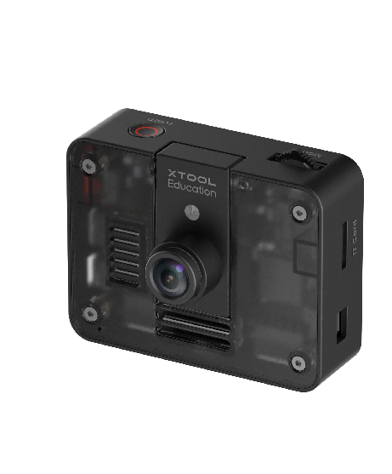

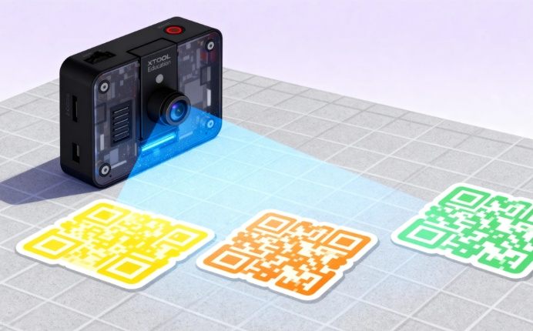
Objectives:
By the end of class, students will be able to:
- Understand the fundamental principles and application scenarios of tag detection
- Use the AI Camera to recognize tags such as AprilTag or QR Code

Overview
This course uses a competitive game approach to guide students in exploring the tag recognition functionality of the AI Camera. Students will learn how to attach tags with different IDs to the six surfaces of a cube and implement rapid tag detection and ID reading through programming.

Pre-lesson Checklist
For the teacher:
- Computer with mBlock installed and tested;
- AI Camera, CyberPi, and connecting cables;
- A cube with six different numeric tags attached to its surfaces;
For the students:
- Computer with mBlock installed and ready;
- One set of CyberPi and AI Camera per group;
- Connecting cables;
- Pre-printed AprilTags;
- Foam cube blocks;
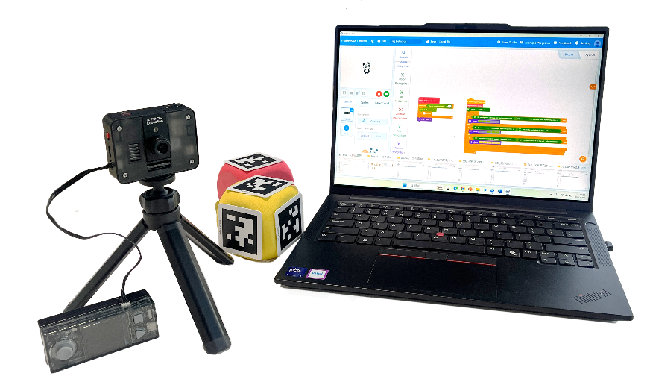

Agenda (45minutes)
Duration | Content
5 minutes | Section 1 - Introduction  - Demonstrate how the AI Camera can quickly read QR code information and display it on the screen;  - Prompt interaction: “How does the AI Camera rapidly 'read' the digital information on tags?”
10 minutes | Section 2 - Explore  - Understand the basic principles of tag recognition: pattern encoding and ID decoding;
15 minutes | Section 3 - Create and practice  - Set up the programming environment and activate the tag recognition function;  - Program to read tag IDs and display them on the screen;
10 minutes | Section 4 - Presentation  - Design a two-player game logic: compare tag ID sizes and determine the winner;  - Invite groups to demonstrate their creative projects;
5 minutes | Section 5 - Evaluate  - Explore what types of interactive games or practical tools can be designed using the tag recognition function;  - Discuss real-world applications of tag recognition technology;

Activities

Section 1 - Introduction
In this lesson, we will explore an efficient and practical function of the AI Camera—tag recognition. You will observe how the camera instantly displays the hidden digital ID from a specially patterned QR code tag on the screen.
This leads to today’s core question: “How does the AI Camera ‘read’ the digital information in tags almost instantly?” It does not rely on text but recognizes a specific type of graphical encoding. Next, we will uncover the principles behind this technology and program our own tag recognition project.

Section 2 - Explore
The AI Camera’s ability to quickly read tag information relies on a technology called Tag Detection, which is based on pattern encoding and ID decoding.
Basic Principles of Tag Recognition
Common tag systems (such as AprilTag or QR Code) do not directly store numbers. Instead, they convert information into a matrix pattern of black and white squares using specific algorithms. Each unique pattern corresponds to a unique digital ID.
Pattern Positioning and Decoding
The camera first quickly locates the specific contour of the tag in the image, then identifies the arrangement of the internal black and white squares. Based on predefined encoding rules, the system decodes the visual pattern and restores it to its corresponding digital ID.

Section 3 – Create and practice
In this section, students will transition from theory to practice, working in small groups to hands-on build and program a unique gesture control system for their mBot2 car.
Task 1: Set up the programming environment and activate tag recognition
Step 1: Add extension modules. Add the [AI Camera 2.0] extension modules in the mBlock 5 programming environment.  Step 2: Tag recognition function activation.Write initialization commands to configure the camera connection port and activate the tag recognition function. Ensure the CyberPi screen displays "Tag Ready" at program startup, indicating successful activation of the tag recognition system. | 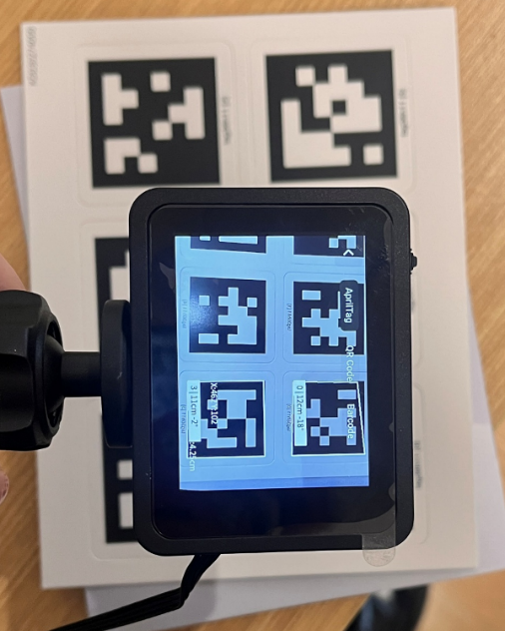

Task 2: Program AprilTag reading and display
Step 3: Use a loop structure to continuously obtain tag IDs recognized by the AI Camera. Implement conditional statements to ensure that numeric IDs are displayed on the CyberPi screen only when valid tags are detected. | 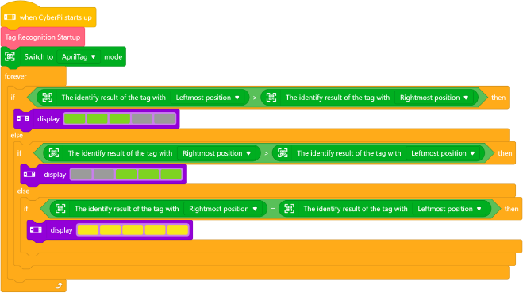

Section 4 - Presentation
In this session, we invite each group to demonstrate their completed tag-based competitive game. Please focus on showing: the accuracy and response speed of tag recognition, and whether game result determination is clear and accurate.
After 2-3 groups have presented, the teacher will lead a discussion: in what other fields can tag recognition technology be applied in practical applications?

Section 5 - Evaluate
Now let's review some key points in this lesson.
- What features or improvements would you add to further optimize this game?
- What other application possibilities does tag recognition technology have in real life? What new opportunities or challenges might its development bring?

